**Question No 7:**

**Question No 3 Visualization Graph:**

**Veggies Dataset:**

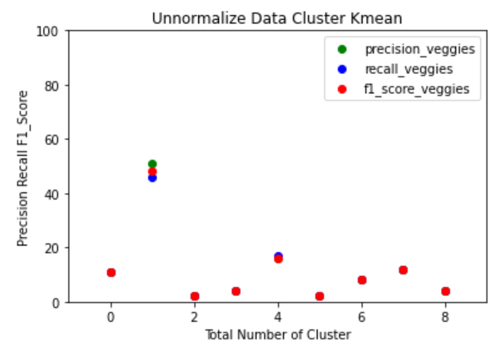

**Animals Dataset:**

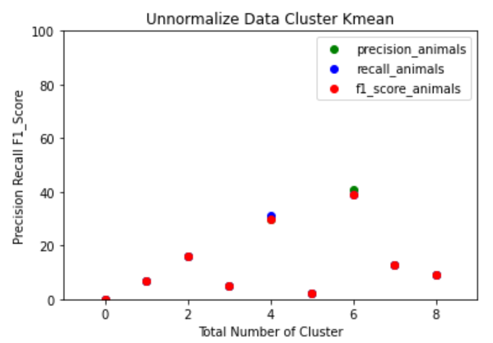

**Fruits Dataset:**

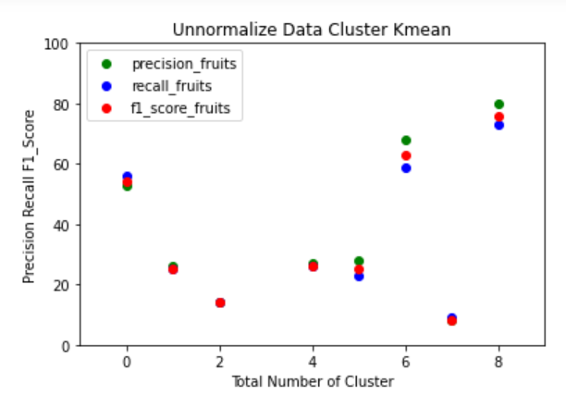

**Countries Dataset:**

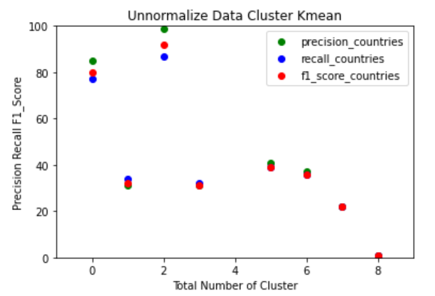

**Question No 6 Visualization Graph:**

**Veggies Dataset:**

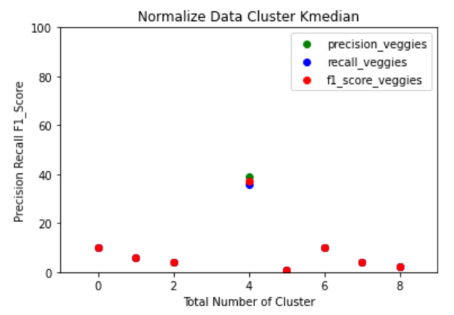

**Animals Dataset:**

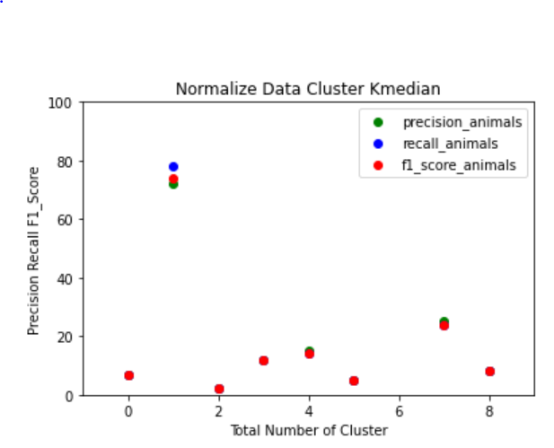

**Fruits Dataset:**

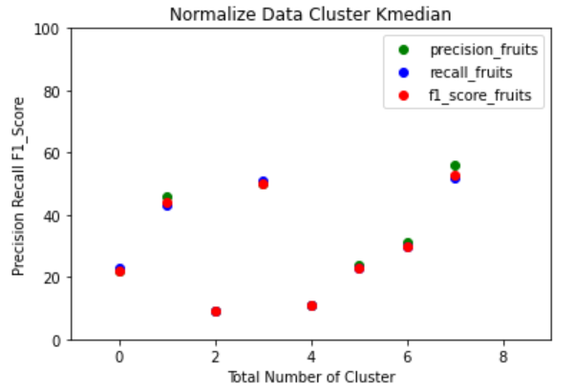

**Countries Dataset:**

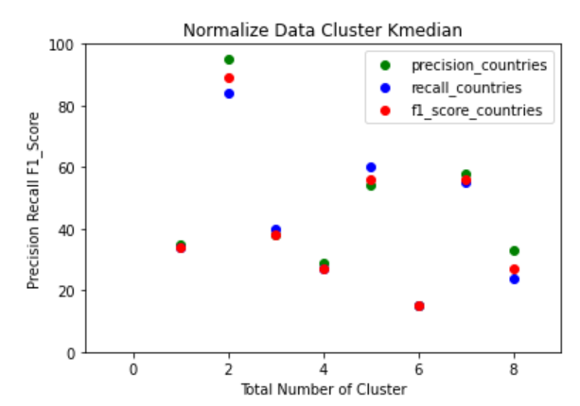

**Un-Normalized data is not showing good results but normalized data is showing good results as we divided the data into ranges, because of this, the precisions, recalls and F1 Score is showing good results compared to the un-normalized data of precisions , recalls and F1 Score.**